Hands-On Assignment 3: Creating a Simple Q&A Chatbot
with Python and ChatterBot

Xhon Pelushi
University of the Cumberlands
MSCS-633-M20: Advance Artificial Intelligence
Hands-On Assignment 3
Dr. Ulrich Vouama
October 3, 2026

Introduction
A chatbot answers in one of two ways. A rule-based bot matches the user's text against patterns an author wrote by hand and returns the reply attached to whichever pattern fires. A retrieval-based bot stores a corpus of statements together with the responses that actually followed them, and when new input arrives it searches that corpus for the closest known statement and returns one of the replies on record. ChatterBot belongs to the second category, which is why its documentation describes it as a machine-learning conversational dialog engine rather than a scripting tool (Cox, n.d.).
That distinction matters for this assignment because it determines where the work goes. No response text is written anywhere in the program below. The developer's job is to choose what the bot is trained on, decide how similar an incoming question must be before the bot is willing to answer, and decide what it should say when nothing is close enough. This report covers the environment and manifest, the design of the terminal client, the coding practices it follows, and the behavior observed when the program is actually run. The source code is published at the repository URL given in the final section.
Development Environment and Manifest
The application was developed and tested on Ubuntu 24.04 with Python 3.12.3. All dependencies were installed into a dedicated virtual environment to keep the project isolated and reproducible. The requirements.txt manifest file lists every package and its pinned version so that the environment can be recreated on any machine with a single pip install command.
Version selection was the one genuinely consequential decision here. ChatterBot 1.0.x, which most tutorials still reference, does not install on Python 3.12: it pins obsolete releases of its own dependencies and fails during resolution. The maintained 1.2.x line installs cleanly, and the manifest therefore pins 1.2.15 explicitly rather than accepting whatever version pip resolves to.
The manifest, requirements.txt, declares the following:
ChatterBot==1.2.15
chatterbot-corpus==1.3.3
PyYAML==6.0.3
Django==6.1.1
spacy==3.8.16
SQLAlchemy==2.0.54
Two entries deserve comment. PyYAML is an optional dependency of ChatterBot and is not installed automatically, but the training corpora are YAML files; without it the first training run fails with OptionalDependencyImportError. This was encountered during development and is the reason the package is pinned in the manifest rather than left implicit. Django is installed because the assignment's technical requirements call for it. ChatterBot can store its knowledge base through either a Django ORM backend or a SQLAlchemy one; this client uses the SQLAlchemy adapter, so Django is present in the environment but is not imported at runtime.
The spaCy language model is fetched separately because it is distributed as a release asset rather than through the package index. Figure 1 shows the full setup.
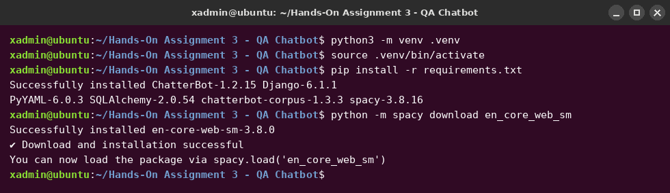
Figure 1. Virtual environment, manifest install, and spaCy model download.
Program Design
The program, qa_chatbot.py, is organized into four small functions so that each concern can be read and changed independently: build_chatbot configures the engine, train loads the corpora, chat_loop runs the terminal session, and main wires them together according to the command-line flags.
The bot is constructed with a SQL storage adapter pointed at a SQLite file stored beside the script. Persisting the knowledge base means training is paid for once rather than on every launch, and resolving the path relative to the script rather than the working directory means the program behaves identically no matter where it is invoked from.
The logic adapter is BestMatch, configured with two settings that together determine how the bot handles ignorance. A maximum similarity threshold of 0.65 tells the engine to treat anything less similar than that as no match at all, and a default response supplies what it should say in that case. Left unconfigured, BestMatch always returns its nearest neighbor however distant, which produces fluent and entirely unrelated answers. Setting the threshold is what allows the bot to say it does not know, and Figure 3 shows that behavior triggering on an unfamiliar question.
Training draws on five English corpora — greetings, conversations, computers, science, and humor — chosen so that the bot can handle both ordinary small talk and the kind of factual question the assignment's sample dialogue implies.
Coding Practices
The module follows PEP 8 layout and naming throughout (Van Rossum et al., 2001). Every function carries a docstring stating what it does and, where the reasoning is not obvious from the code, why it is written that way; the comment on the confidence threshold explains the failure it prevents rather than restating the assignment.
Configuration values that a reader might want to change — the database path, the corpora list, the threshold, the default response, and the set of exit commands — are named constants at the top of the file rather than literals buried in function bodies. Input is handled defensively: empty lines are skipped instead of being sent to the matcher, exit words are compared case-insensitively, and KeyboardInterrupt and EOFError are caught so that pressing Ctrl-C or Ctrl-D ends the session with a goodbye rather than a traceback.
The command-line interface uses argparse with a mutually exclusive group, so --no-train and --retrain cannot be combined (Python Software Foundation, n.d.). One combination still needs guarding: --no-train when no database exists would otherwise start a bot that silently knows nothing. The program detects that case, explains it on standard error, and exits with status 1, which Figure 4 demonstrates.
Results
Figure 2 shows the first run. Training the five corpora completes in under a second, after which the client accepts the sample exchange given in the assignment brief. The greeting is answered conversationally, the factual question about computers returns a definition drawn from the computers corpus, and the request for a joke returns one from the humor corpus.
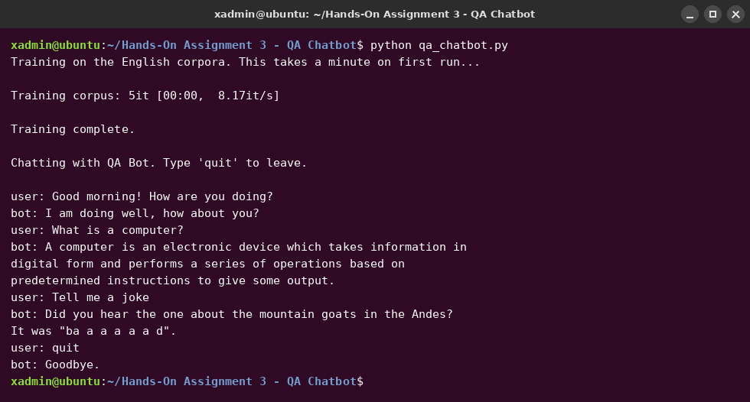
Figure 2. First run: corpus training followed by the sample conversation.
Figure 3 shows a second session started with --no-train. Startup is immediate because the SQLite database written by the first run is reused, confirming that the knowledge base persists. This session also exercises the confidence threshold: a question about unladen swallows appears nowhere in the training data, and rather than returning the nearest unrelated statement the bot falls back to its default response. The subsequent greeting is answered normally, showing that the threshold suppresses only genuinely poor matches.
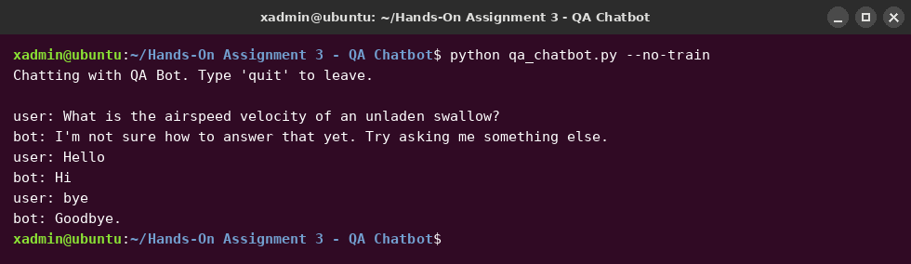
Figure 3. Database reuse with --no-train, and the confidence threshold rejecting an unknown question.
Figure 4 shows the command-line interface and the guarded error path described above.
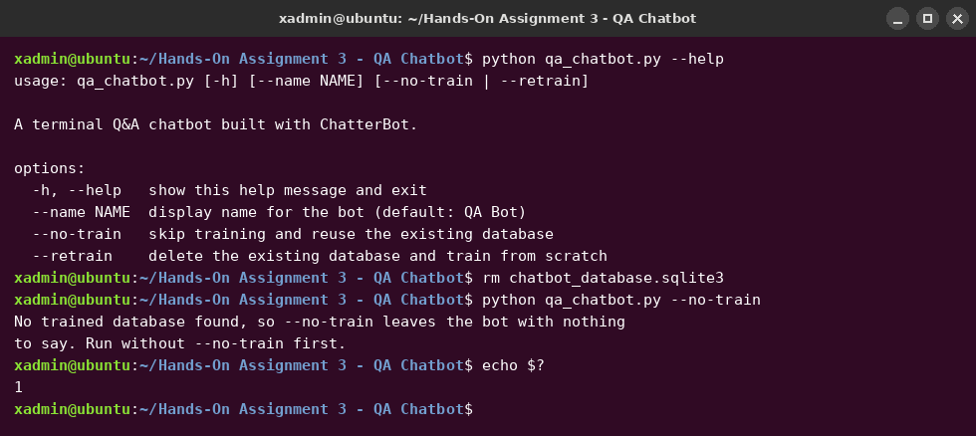
Figure 4. Command-line help and the --no-train guard exiting with status 1.
Source Code Repository
The source code, manifest, and screenshots are published in the course repository at the following URL:
https://github.com/xhon-pelushi/MSCS-633-Advance-Artificial-Intelligence
Conclusion
The finished program does what the assignment asked: it is a terminal client that holds a conversation with a ChatterBot-backed bot, and the sample exchange from the brief runs through it unmodified. The parts that took actual engineering judgment were not the conversation itself, which the library handles, but the decisions surrounding it — pinning a ChatterBot version that installs on a current interpreter, discovering that corpus training needs a dependency the package does not declare, setting a similarity threshold so the bot declines to answer rather than bluffing, and making the one invalid flag combination fail loudly instead of quietly. A retrieval-based bot is only as good as what it was trained on and as honest as its threshold allows, and both of those are the developer's responsibility rather than the library's.

References
Cox, G. (n.d.). ChatterBot: Machine learning, conversational dialog engine [Computer software documentation]. Read the Docs. https://chatterbot.readthedocs.io/
Django Software Foundation. (n.d.). Django documentation. https://docs.djangoproject.com/
ExplosionAI. (n.d.). spaCy: Industrial-strength natural language processing. https://spacy.io/
Python Software Foundation. (n.d.). argparse — Parser for command-line options, arguments and subcommands. https://docs.python.org/3/library/argparse.html
Van Rossum, G., Warsaw, B., & Coghlan, N. (2001). PEP 8 — Style guide for Python code. Python Software Foundation. https://peps.python.org/pep-0008/

